|  |  |  |
| --- | --- | --- |
| **Sr. No.** | **Contents** | **Page No.** |
| **1** | **Annexure I– Micro Project Proposal** | **1-2** |
| 1.Aims/Benefits of the Micro-Project | 1 |
| 2. Course Outcome Addressed | 1 |
| 3.Proposed Methodology | 1 |
| 4. Action Plan | 2 |
| 5. Resources Required | 2 |
| 6. Name of Team Members with Roll No.’s | 2 |
| **2** | **Annexure II – Micro Project Report** | **3-8** |
| 1.Rationale | 3 |
| 2.Aims/Benefits of the Micro-Project | 3 |
| 3.Course Outcome Achieved | 3 |
| 4. Literature Review | 4 |
| 5.Actual Methodology Followed | 5 |
| 5.1 Flow chart | 5 |
| 5.2 Source code | 6-8 |
| 6.Actual  Resources Used | 9 |
| 7.Outputs of Micro-Projects | 9 |
| 8. Skill developed / Learning out of this Micro-Project | 13 |
| 9. Applications of this Micro-Project | 13 |

**Annexure I**

**Micro Project Proposal**

**Calculator by using Switch Case**

**1. Aims/Benefits of the Micro-Project:**

1. Understanding the switch case statements and its applications like simple Calculator.

2. To find algebraic operation result by using switch program.

3. To understand the data structure, flow chart and execution of the switch

**2. Course Outcome Addressed:**

1) CO1-Interpret the basic code of 'C'

2) CO2- Implement decision making in 'C' programming

3) CO3-Use arrays and string in 'C' programming

4) CO4- Use functions in 'C' programs for modular programming approach

5) CO5- Use pointers to increase efficiency of programs

6) CO6- Implement basic concept of structure in 'C'

**3. Proposed Methodology:**

Here we are using switch statements to create Calculator.

We have added functions (like + to add , - to subtract and * to multiplay)

And many more.

Calculator perform chosen operation on given operants and give output to us with answer and its statement also.

**4.Action Plan**:

|  |  |  |  |  |
| --- | --- | --- | --- | --- |
| **Sr.**  **No.** | **Details of Activity** | **Planned**  **Start date** | **Planned**  **Finish date** | **Name of Responsible Team Members** |
| 1 | Search the topic | 06/04/2021  4:00pm-5:00pm | 13/04/2021  4:00pm-5:00pm |  |
| 2 | Search the information | 20/04/2021  4:00pm-5:00pm | 27/04/2021  4:00pm-5:00pm |  |
| 3 | Algorithm developing | 04/05/2021  4:00pm-5:00pm | 08/05/2021  4:00pm-5:00pm |  |
| 4 | Flowchart developing | 11/05/2021  4:00pm-5:00pm | 15/05/2021  4:00pm-5:00pm |  |
| 5 | Function making | 18/05/2021  4:00pm-5:00pm | 22/05/2021  4:00pm-5:00pm |  |
| 6 | Coding developing | 25/05/2021  4:00pm-5:00pm | 29/05/2021  4:00pm-5:00pm |  |
| 7 | Debugging | 01/06/2021  4:00pm-5:00pm | 05/06/2021  4:00pm-5:00pm |  |
| 8 | Finalizing Project with its report | 07/06/2021  4:00pm-5:00pm | 09/06/2021  4:00pm-5:00pm |  |

**5. Resources Required:**

|  |  |  |  |  |
| --- | --- | --- | --- | --- |
| **Sr.**  **No.** | **Name of resource / material** | **Specification** | **Quantity** | **Remarks** |
| 1 | Computer | WINDOWS 7,2GB RAM, 160GB HDD | 1 |  |
| 2 | Operating System | WINDOWS 7 | 1 |  |
| 3 | Compiler | Turbo C/GCC | 1 |  |
| 4 | Browser | Chrome | 1 |  |

**Names of Team Members with Roll No.’s:**

|  |  |  |  |
| --- | --- | --- | --- |
| **Sr.**  **No.** | **Enrollment No.** | **Name of Team Member** | **Roll No.** |
| 1 |  |  |  |
| 2 |  |  |  |
| 3 |  |  |  |
| 4 |  |  |  |
| 5 |  |  |  |

**Mr. Kazi A.S.M.**

**Name and Signature of the Teacher**

**Annexure – II**

**Micro-Project Report**

**Simple Calculator by Switch case**

1. **Rationale:**

Creating a simple Calculator to solve some basic operations like addition and sunstraction by using switch statement in Turbo C

**2.Aims/Benefits of the Micro-Project:**

1. Understanding the switch case statements and its applications like simple Calculator.

2. To find algebraic operation result by using switch program.

3. To understand the data structure, flow chart and execution of the switch.

**3. Course Outcomes Achieved:**

1) CO1-Interpret the basic code of 'C'

2) CO2- Implement decision making in 'C' programming

3) CO3-Use arrays and string in 'C' programming

4) CO4- Use functions in 'C' programs for modular programming approach

5) CO5- Use pointers to increase efficiency of programs

6) CO6- Implement basic concept of structure in 'C'

**4. Literature Review:**

Here we are using switch statements to create Calculator.

We have added functions (like + to add , - to subtract and * to multiplay)

And many more.

Calculator perform chosen operation on given operants.

* Switch Statement-

Switch case statements are a substitute for long if statements that compare a variable to several integral values

* The switch statement is a multiway branch statement. It provides an easy way to dispatch execution to different parts of code based on the value of the expression.
* Switch is a control statement that allows a value to change control of execution.

**Syntax:**

switch (n)

{

case 1: // code to be executed if n = 1;

break;

case 2: // code to be executed if n = 2;

break;

default: // code to be executed if n doesn't match any cases

}

**Important Points about Switch Case Statements:**

1. The expression provided in the switch should result in a**constant value** otherwise it would not be valid

**Valid expressions for switch:**

// Constant expressions allowed

switch(1+2+23)

switch(1*2+3%4)

// Variable expression are allowed provided

// they are assigned with fixed values

switch(a*b+c*d)

switch(a+b+c)

1. Duplicate case values are not allowed.
2. The default statement is optional.Even if the switch case statement do not have a default statement,  
   it would run without any problem.
3. The break statement is used inside the switch to terminate a statement sequence. When a break statement is reached, the switch terminates, and the flow of control jumps to the next line following the switch statement.
4. The break statement is optional. If omitted, execution will continue on into the next case. The flow of control will fall through to subsequent cases until a break is reached.
5. Nesting of switch statements are allowed, which means you can have switch statements inside another switch. However nested switch statements should be avoided as it makes program more complex and less readable

**5 Actual MethodologyFollowed:**

**5.1 Flow Chart:**

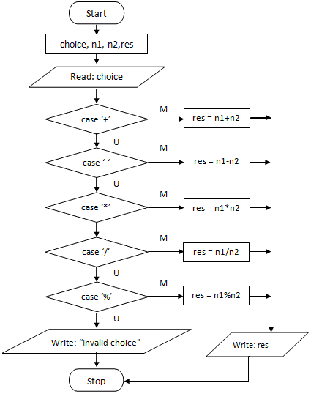

**5.2 Source Code:**

**Simple Calculator using switch Statement**

#include <stdio.h>

#include <conio.h>

#include <math.h>

int main()

{

char operator;

int first, second;

printf("Enter an operator (+, -, *,/,P,S) ");

scanf("%c", &operator);

printf("Enter two operands: ");

scanf("%lf %lf", &first, &second);

p=pow(first,second);

r=sqrt(first);

s=sqrt(second);

switch (operator)

{

case '+':

printf("%d %c %d = %d", first ,function, second, first + second);

break;

case '-':

printf("%d %c %d = %d", first ,function, second, first - second);

break;

case '*':

printf("%d %c %d = %d", first ,function, second, first * second);

break;

case '/':

printf("%d %c %d = %d", first,function, second, first / second);

break;

case 'P':

printf("%d %c %d = %d", first,function, second, first / second);

break;

case 'R':

printf("%d %c %d = %d", first,function, second, first / second);

break;

default:

printf("Invalid");

}

Getch();

}

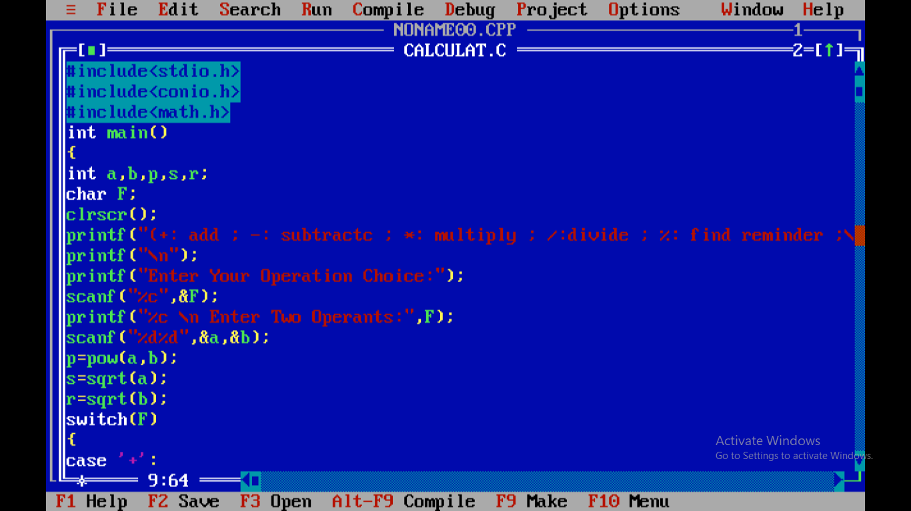

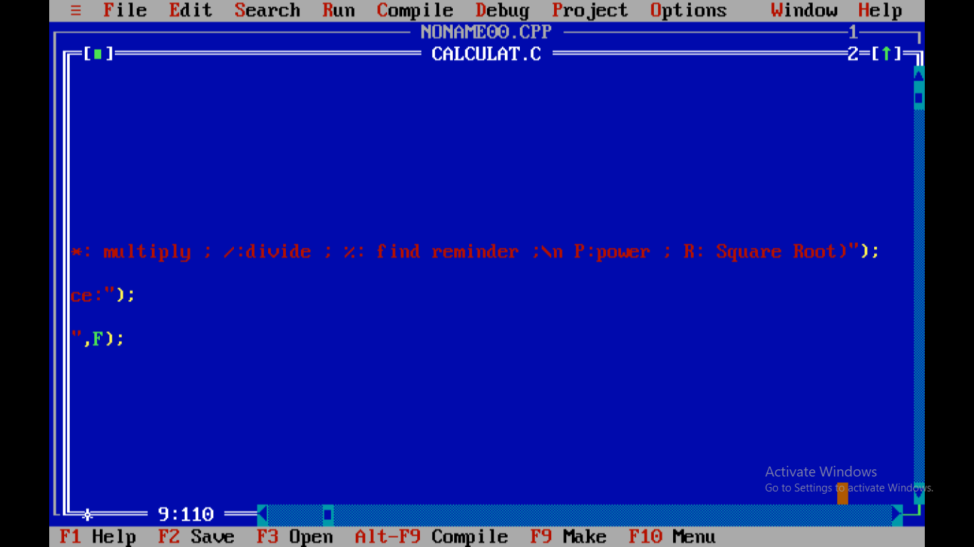

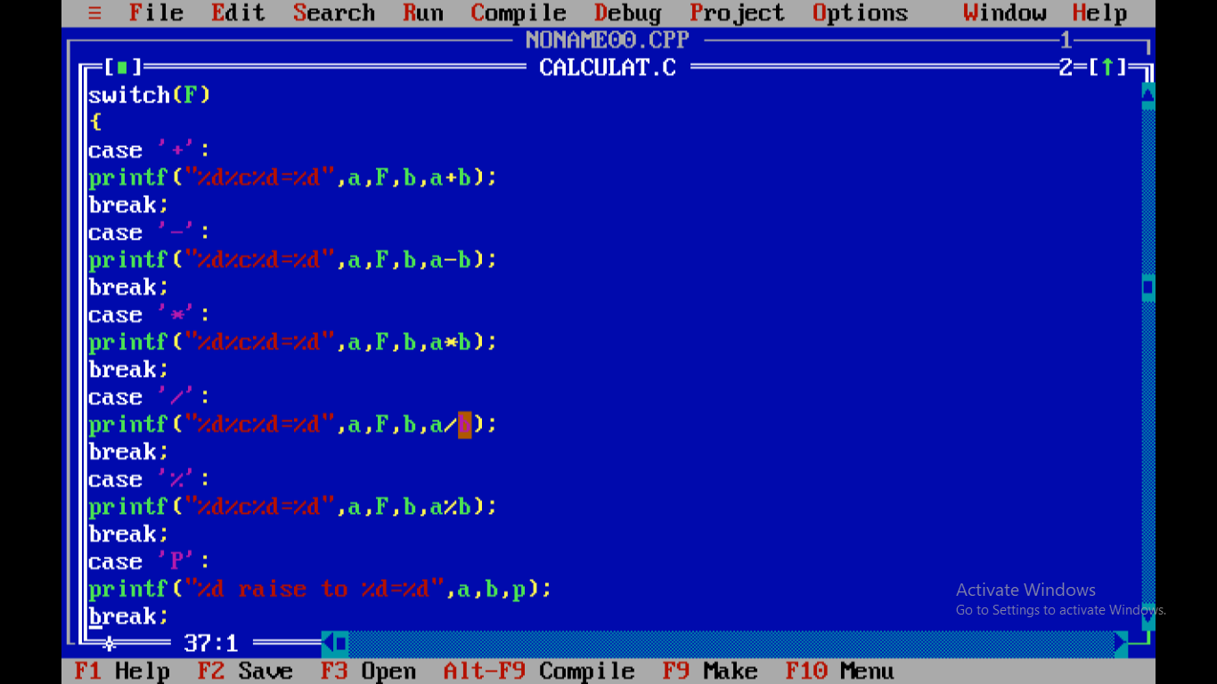

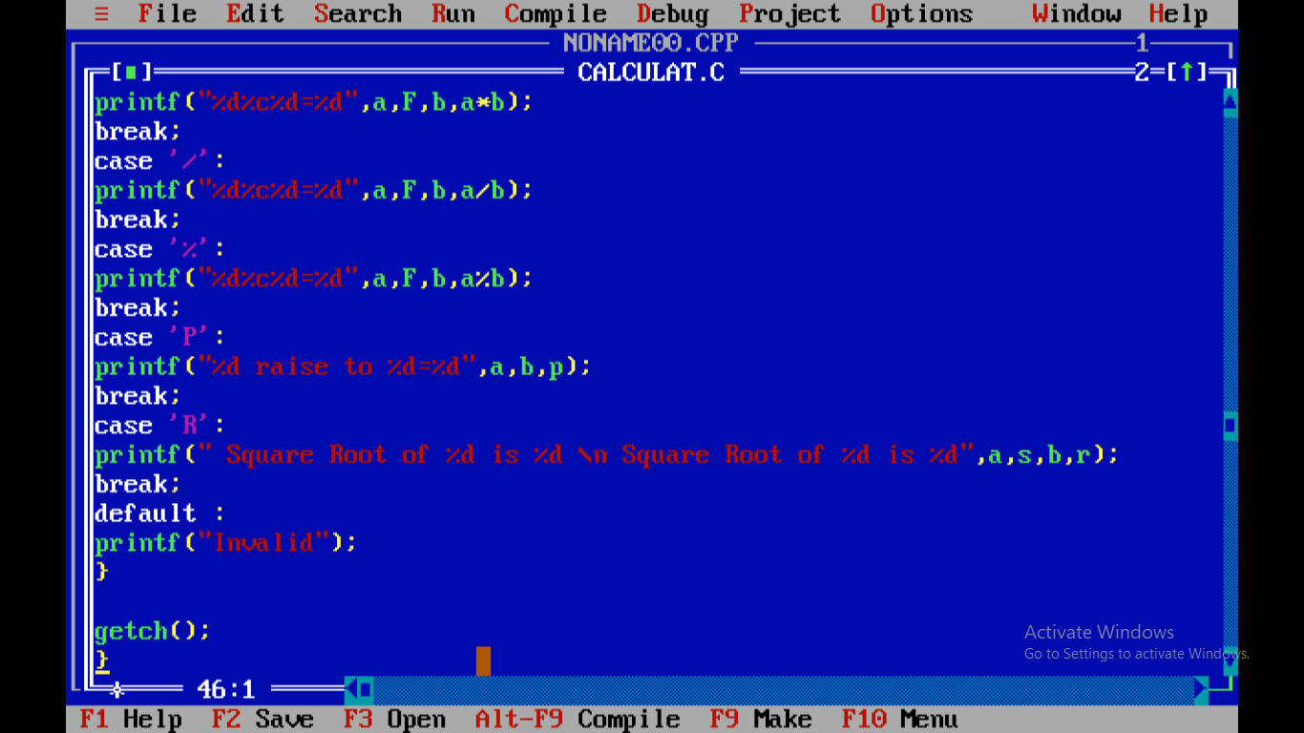

**6. Actual Resources Used:**

|  |  |  |  |  |
| --- | --- | --- | --- | --- |
| **Sr.**  **No.** | **Name of resource / material** | **Specification** | **Quantity** | **Remarks** |
| 1 | Computer | WINDOWS 7,2GB RAM, 160GB HDD | 1 |  |
| 2 | Operating System | WINDOWS 7 | 1 |  |
| 3 | Compiler | Turbo C/GCC | 1 |  |
| 4 | Browser | Chrome | 1 |  |

**7.Outputs of Micro-Projects:**

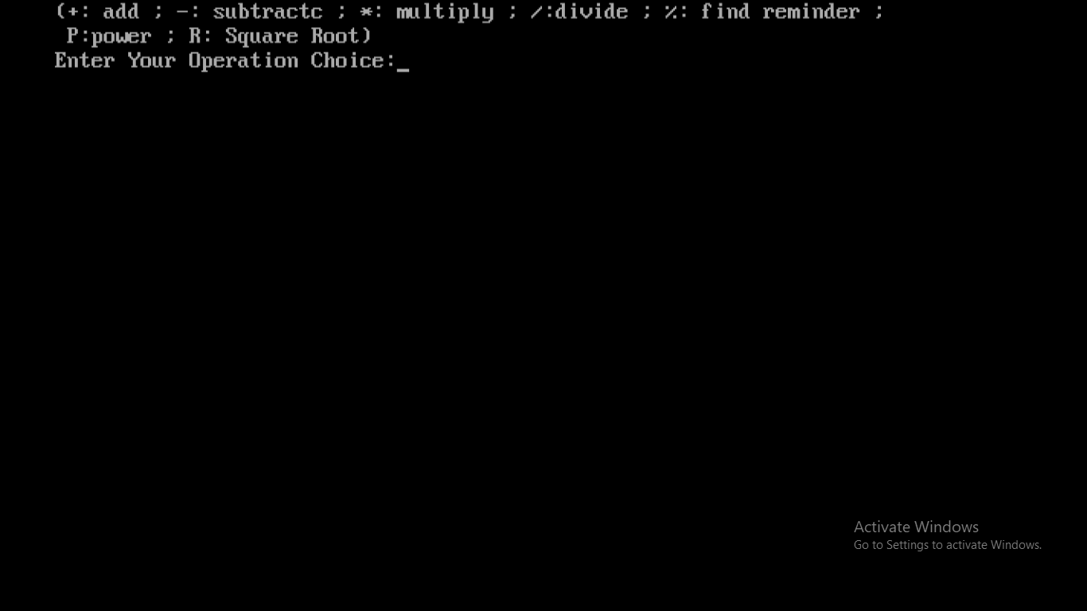

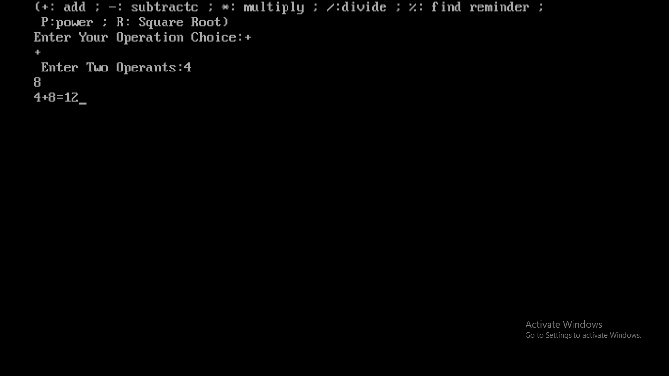

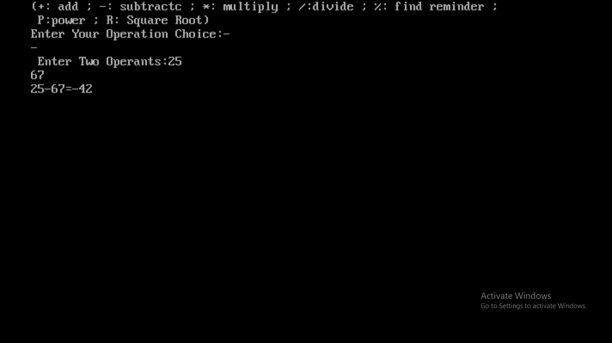

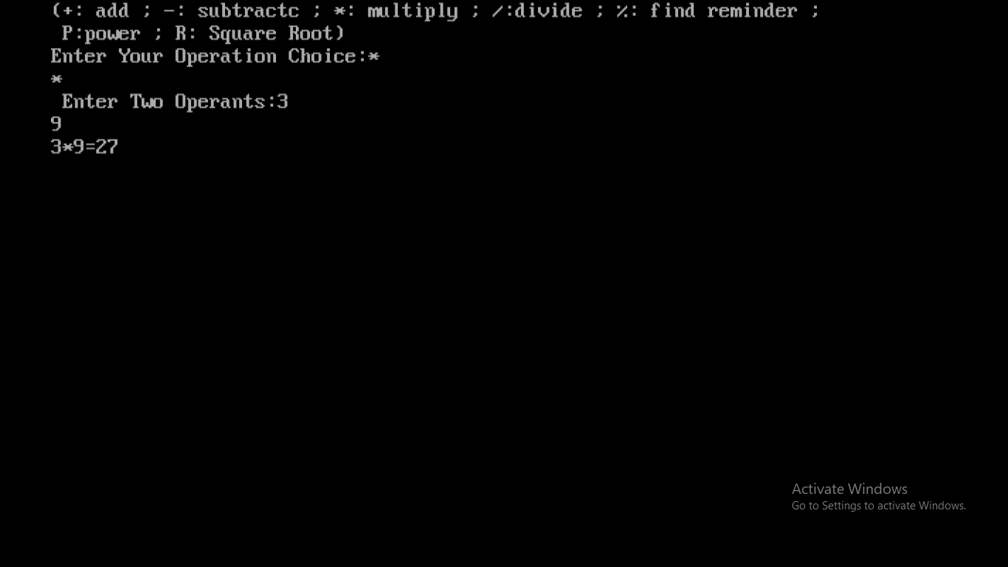

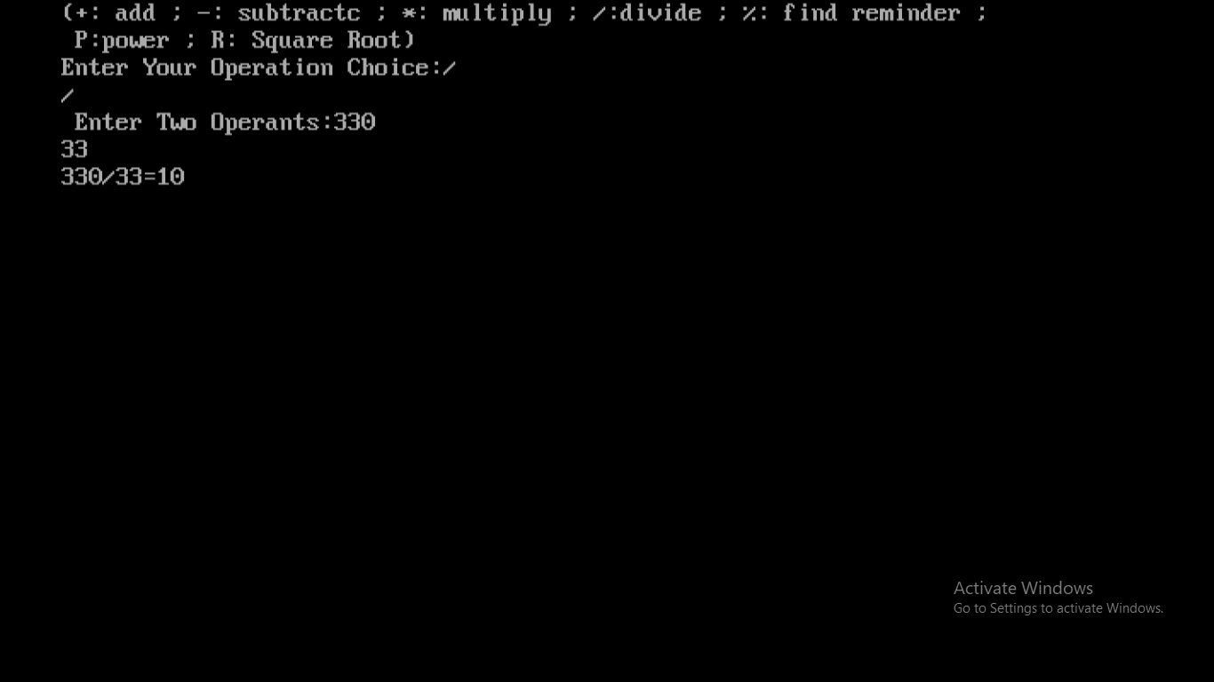

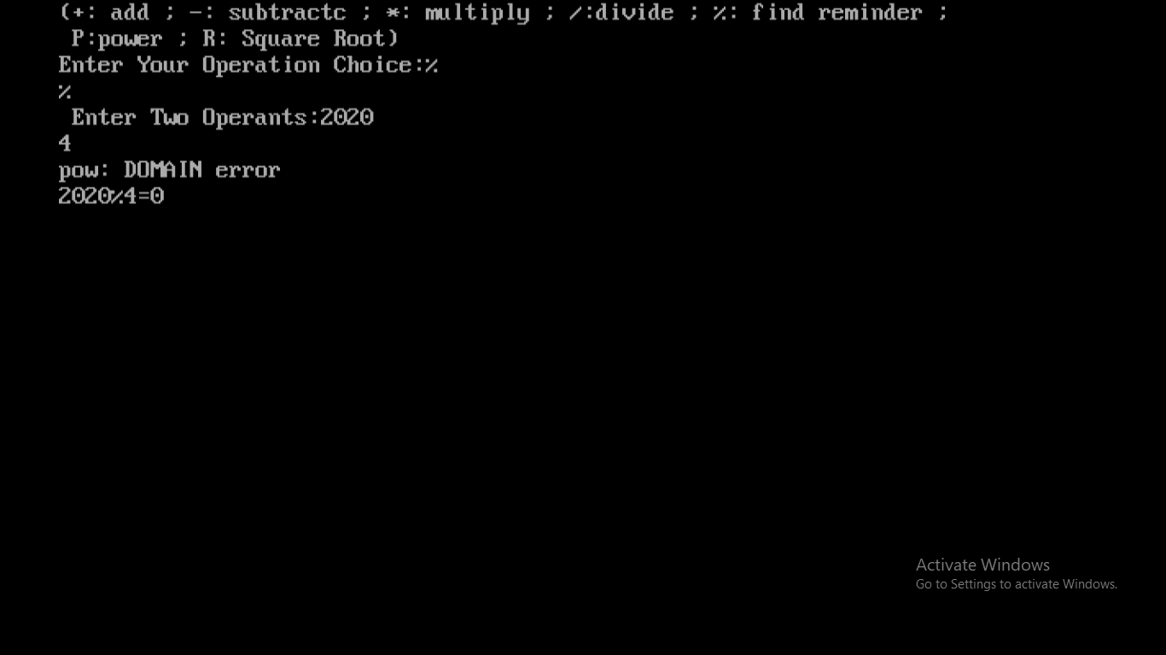

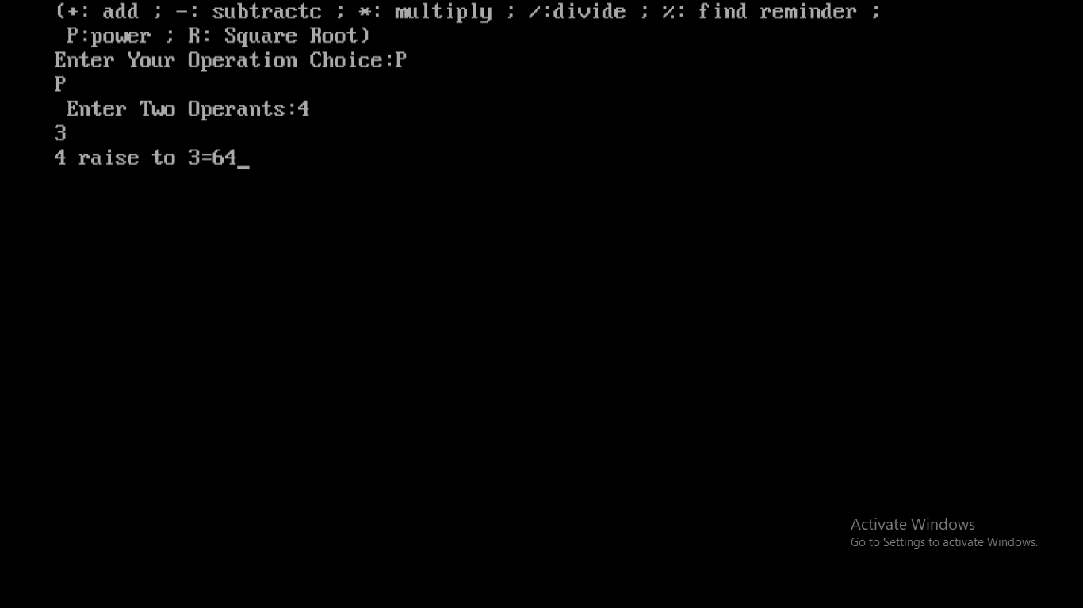

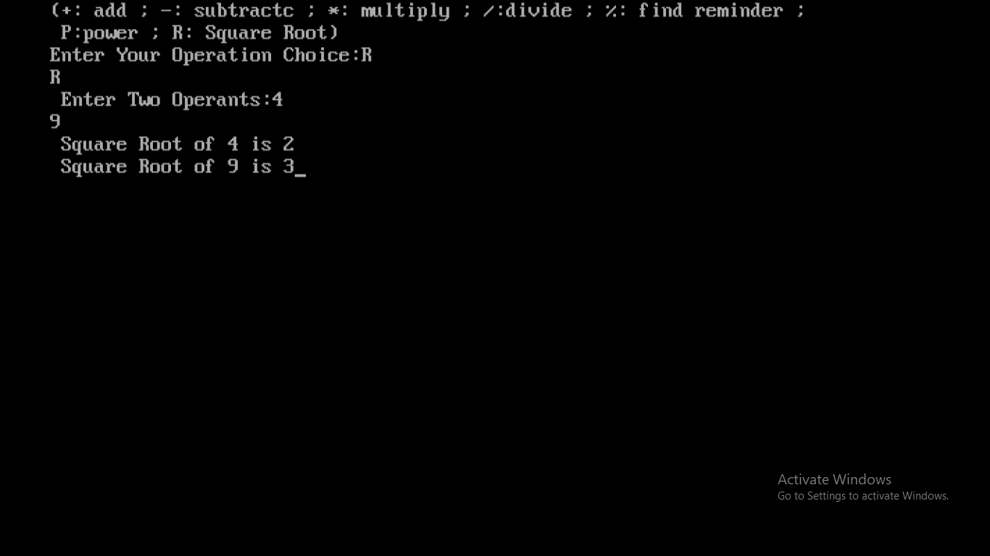

**8.Skill developed / Learning out of this Micro-Project:**

There are so many thing that we learn from this project of

1. We learn that how to make the project in c programming.

2. How to do the testing of program in turbo c.

3. How to collect the information and how to make the presentation that we learn from this project.

4. We develop our logic implementation for programing and coding.

5. We learn to use switch case statements.

6. We learn how to use correct data type in program.

7. We learn some keywords from ‘conio.h’ header file.

8. This all thing we learn from this project.

**9. Applications of this Micro-Project:**

1. It can be used to calculate algebraic functions such as addition and subtraction.
2. It can also be used to calculate some mathematical terms like square function, power function, square root function etc.
3. It can also be used to calculate reminder.

*********